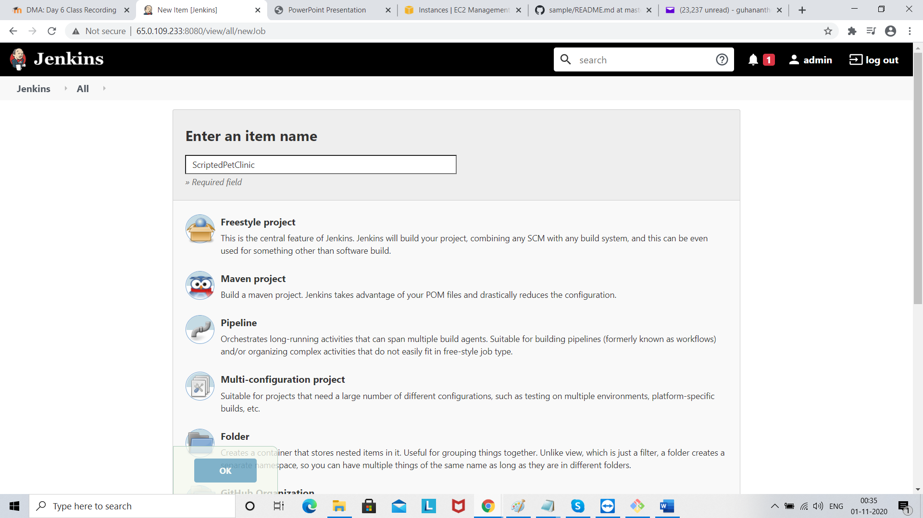

Select pipeline and click ok

Then go to pipeline and paste code from Code is available in DevOpsMasterJenkins/ScriptedPetClinic/pipeline.txt

Change script to test as shown below

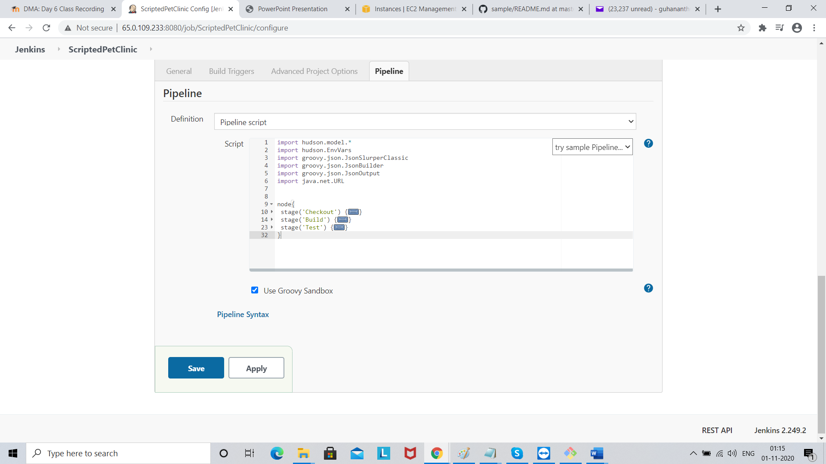

Click Save

Build it

